Guide to Ingame Time

Video guide can be found here:
https://www.youtube.com/watch?v=x2l4s543ytw

Original Reddit post:
https://www.reddit.com/r/thedivision/comments/o0a3x0/the_craziness_that_is_division_2s_ingame_hours/

Ingame time is viewable at the top right of the main menu, it is also viewable in the upper right in photo mode.
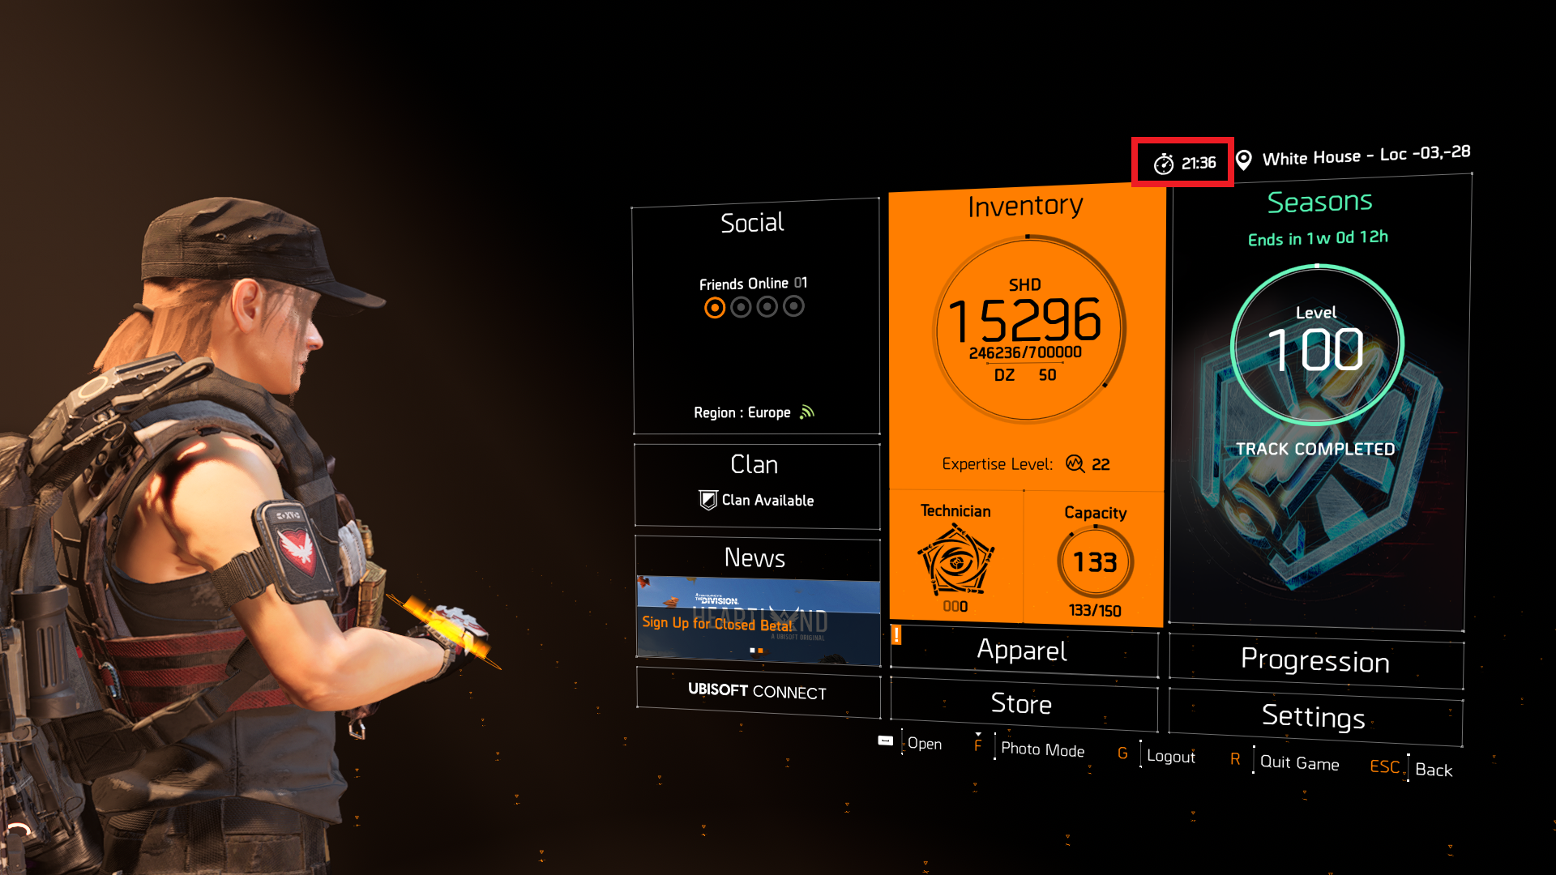

An ingame day is 72 minutes and an ingame hour varies between 1m47s to 5m21s, averaging to 3 minutes per hour.

Every hour ingame hour is a set length within a day, but varies per hour, here is a chart visualizing the length of each hour within a day:
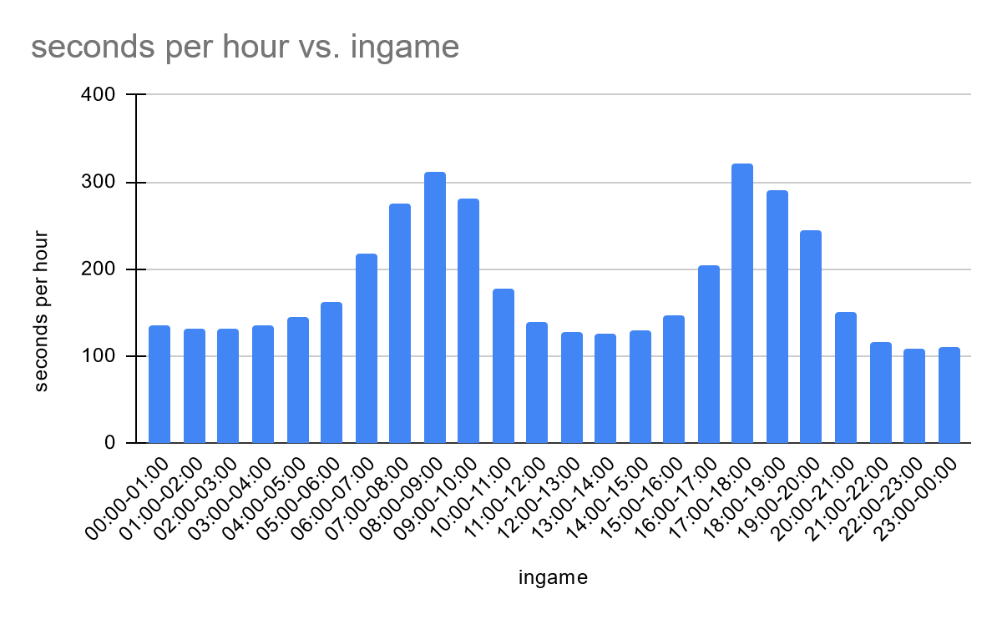
Link to spreadsheet with timed charts : https://docs.google.com/spreadsheets/d/1OdxpgWgY2Mh3SQadzX2lnbY6yW4-SUH-BrVGSABcBr8/edit?usp=sharing

We don’t know the exact reason for why it is done this way, but my speculation is it is to elongate the sunrise and sunset hours, as those are visually the most interesting.

Ingame time is global for all players, and there are only a few sessioned gameplay sections where it isn't using global time, for instance the WONY intro area where you make your way to Haven and a set few others.

There are no ways to accelerate or slow down the passage of time, you just have to wait it out.

